Experiential Learning
Report submitted to the

VIT Bhopal University

B.Tech
in
Artificial Intelligence & Machine Learning

Submitted by

Vijay Rajesh R
23BAI10917

November, 2025

Declaration
I, Vijay Rajesh R, bearing the Registration Number 23 hereby declare that this report of “Experiential Learning” represents my original work carried out as an undergraduate student at VIT Bhopal University. To the best of my knowledge, it contains no material previously published or written by another person, nor any material presented for the award of any other degree of VIT Bhopal University or any other institution. Any contribution made to this report by others, with whom I have worked at VIT Bhopal University or elsewhere, is explicitly acknowledged in the report.

Date: xxxxxxx Vijay Rajesh R

VIT Bhopal University

Acknowledgment

[Write a paragraph of acknowledgment]

jfkrh

Vijay Rajesh R
Summary of Your Experential Learning
[Provide summary of your VITB Experential Learning proceedings emphasizing places visted, perons intecated, training under gone etc. ]

Keywords: Write 5-6 keywords in alphabetical order.

Contents

Description Page No.

Declaration of originality…………………………………
Acknowledgment………………………………………….
Summary ……………………………………………………
Contents……………………………………………………

City Choice – 1 Day – 1 report
1.1.1. Industry Name………………………………………….
1.1.2. Objectives ……………………………………………..
1.1.3. Learning outcome………………………………………
1.1.4. Photographs…………………………………………….
1.1.5. Feedback of the day -1………………………………….
Day – 2 report
1.2.1 Industry Name………………………………………….
1.2.2 Objectives ……………………………………………..
1.2.3 Learning outcome………………………………………
1.2.4 Photographs…………………………………………….
1.2.5 Feedback of the day -2………………………………….
Day – 3 report
1.3.1 Industry Name………………………………………….
1.3.2 Objectives ……………………………………………..
1.3.3 Learning outcome………………………………………
1.3.4 Photographs…………………………………………….
1.3.5 Feedback of the day -3………………………………….

Day – 4 report
1.4.1 Industry Name………………………………………….
1.4.2 Objectives ……………………………………………..
1.4.3 Learning outcome………………………………………
1.4.4 Photographs…………………………………………….
1.4.5 Feedback of the day -4………………………………….

Day – 5 report
1.5.1 Event/Industry Name………………………………….
1.5.2 Objectives ……………………………………………..
1.5.3 Learning outcome………………………………………
1.5.4 Photographs…………………………………………….
1.5.5 Feedback of the day -5………………………………….

City Choice – 2 Day – 1 report
2.1.1 Industry Name………………………………………….
2.1.2 Objectives ……………………………………………..
2.1.3 Learning outcome………………………………………
2.1.4 Photographs…………………………………………….
2.1.5 Feedback of the day -1………………………………….
Day – 2 report
2.2.1 Industry Name………………………………………….
2.2.2 Objectives ……………………………………………..
2.2.3 Learning outcome………………………………………
2.2.4 Photographs…………………………………………….
2.2.5 Feedback of the day -2………………………………….

Day – 3 report
2.3.1 Industry Name………………………………………….
2.3.2 Objectives ……………………………………………..
2.3.3 Learning outcome………………………………………
2.3.4 Photographs…………………………………………….
2.3.5 Feedback of the day -3………………………………….

Day – 4 report
2.4.1 Industry Name………………………………………….
2.4.2 Objectives ……………………………………………..
2.4.3 Learning outcome………………………………………
2.4.4 Photographs…………………………………………….
2.4.5 Feedback of the day -4………………………………….

Day – 5 report
2.5.1 Event/Industry Name………………………………….
2.5.2 Objectives ……………………………………………..
2.5.3 Learning outcome………………………………………
2.5.4 Photographs…………………………………………….
2.5.5 Feedback of the day -5………………………………….

Conclusions:

City Choice – 1
Chennai

Day – 1 report

1.1.1 Motivate to Innovate @ VIT Chennai –

1.1.2 Objectives
- Getting very use information from the profound speaker Dr. Madhan Kumar Srinivasan
- GEtting insighyts about the tech trend around the globe
- GettTTING valuable information from his life

1.1.3 Learning outcome
From the life story of Dr. Madhan, we get to know Bout how hard the life will be and how determining we should be to achieve greater heights. And the technical part, he exam ……………

1.1.4 Photographs
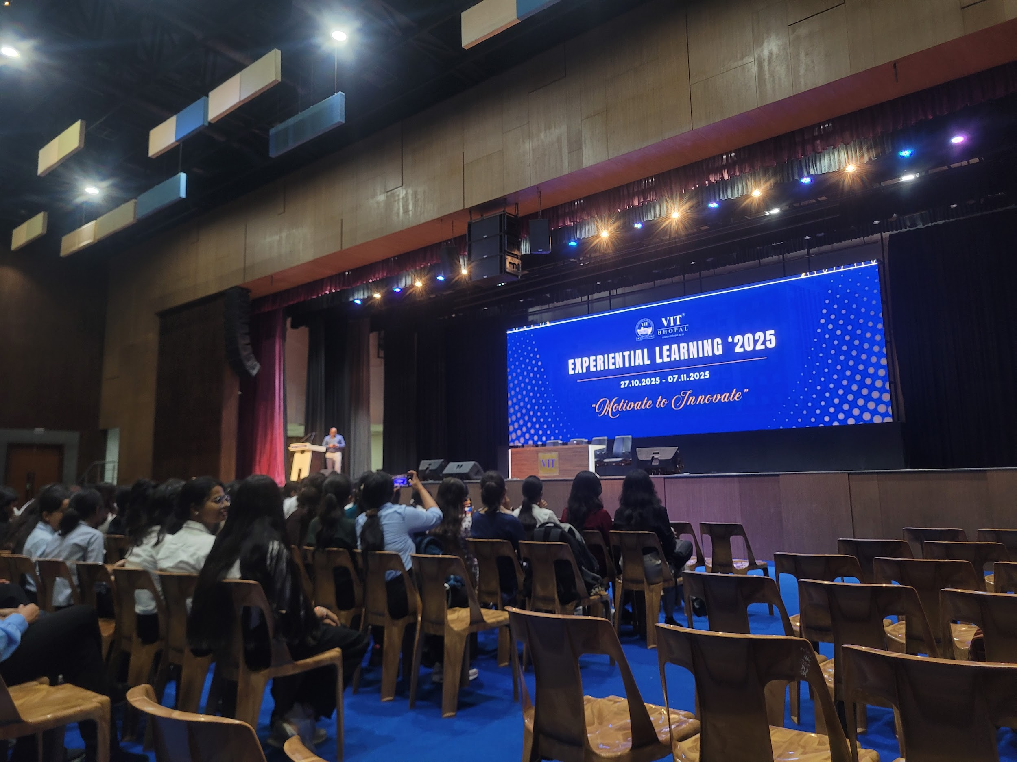

1.1.5 Feedback of the day – 1

.

Day – 2 report

1.2.1 RGMTTC - BSNL

1.2.2 Objectives
To understand networking, bsnl trends, new technologies, traditional methods,
Fibre optics, back up power. Engines in BSNL

1.2.3 Learning outcome

By Learning these ,.... we get….

1.2.4 Photographs (Paste 4-5 good photogrpahs of hands on experience/visit)
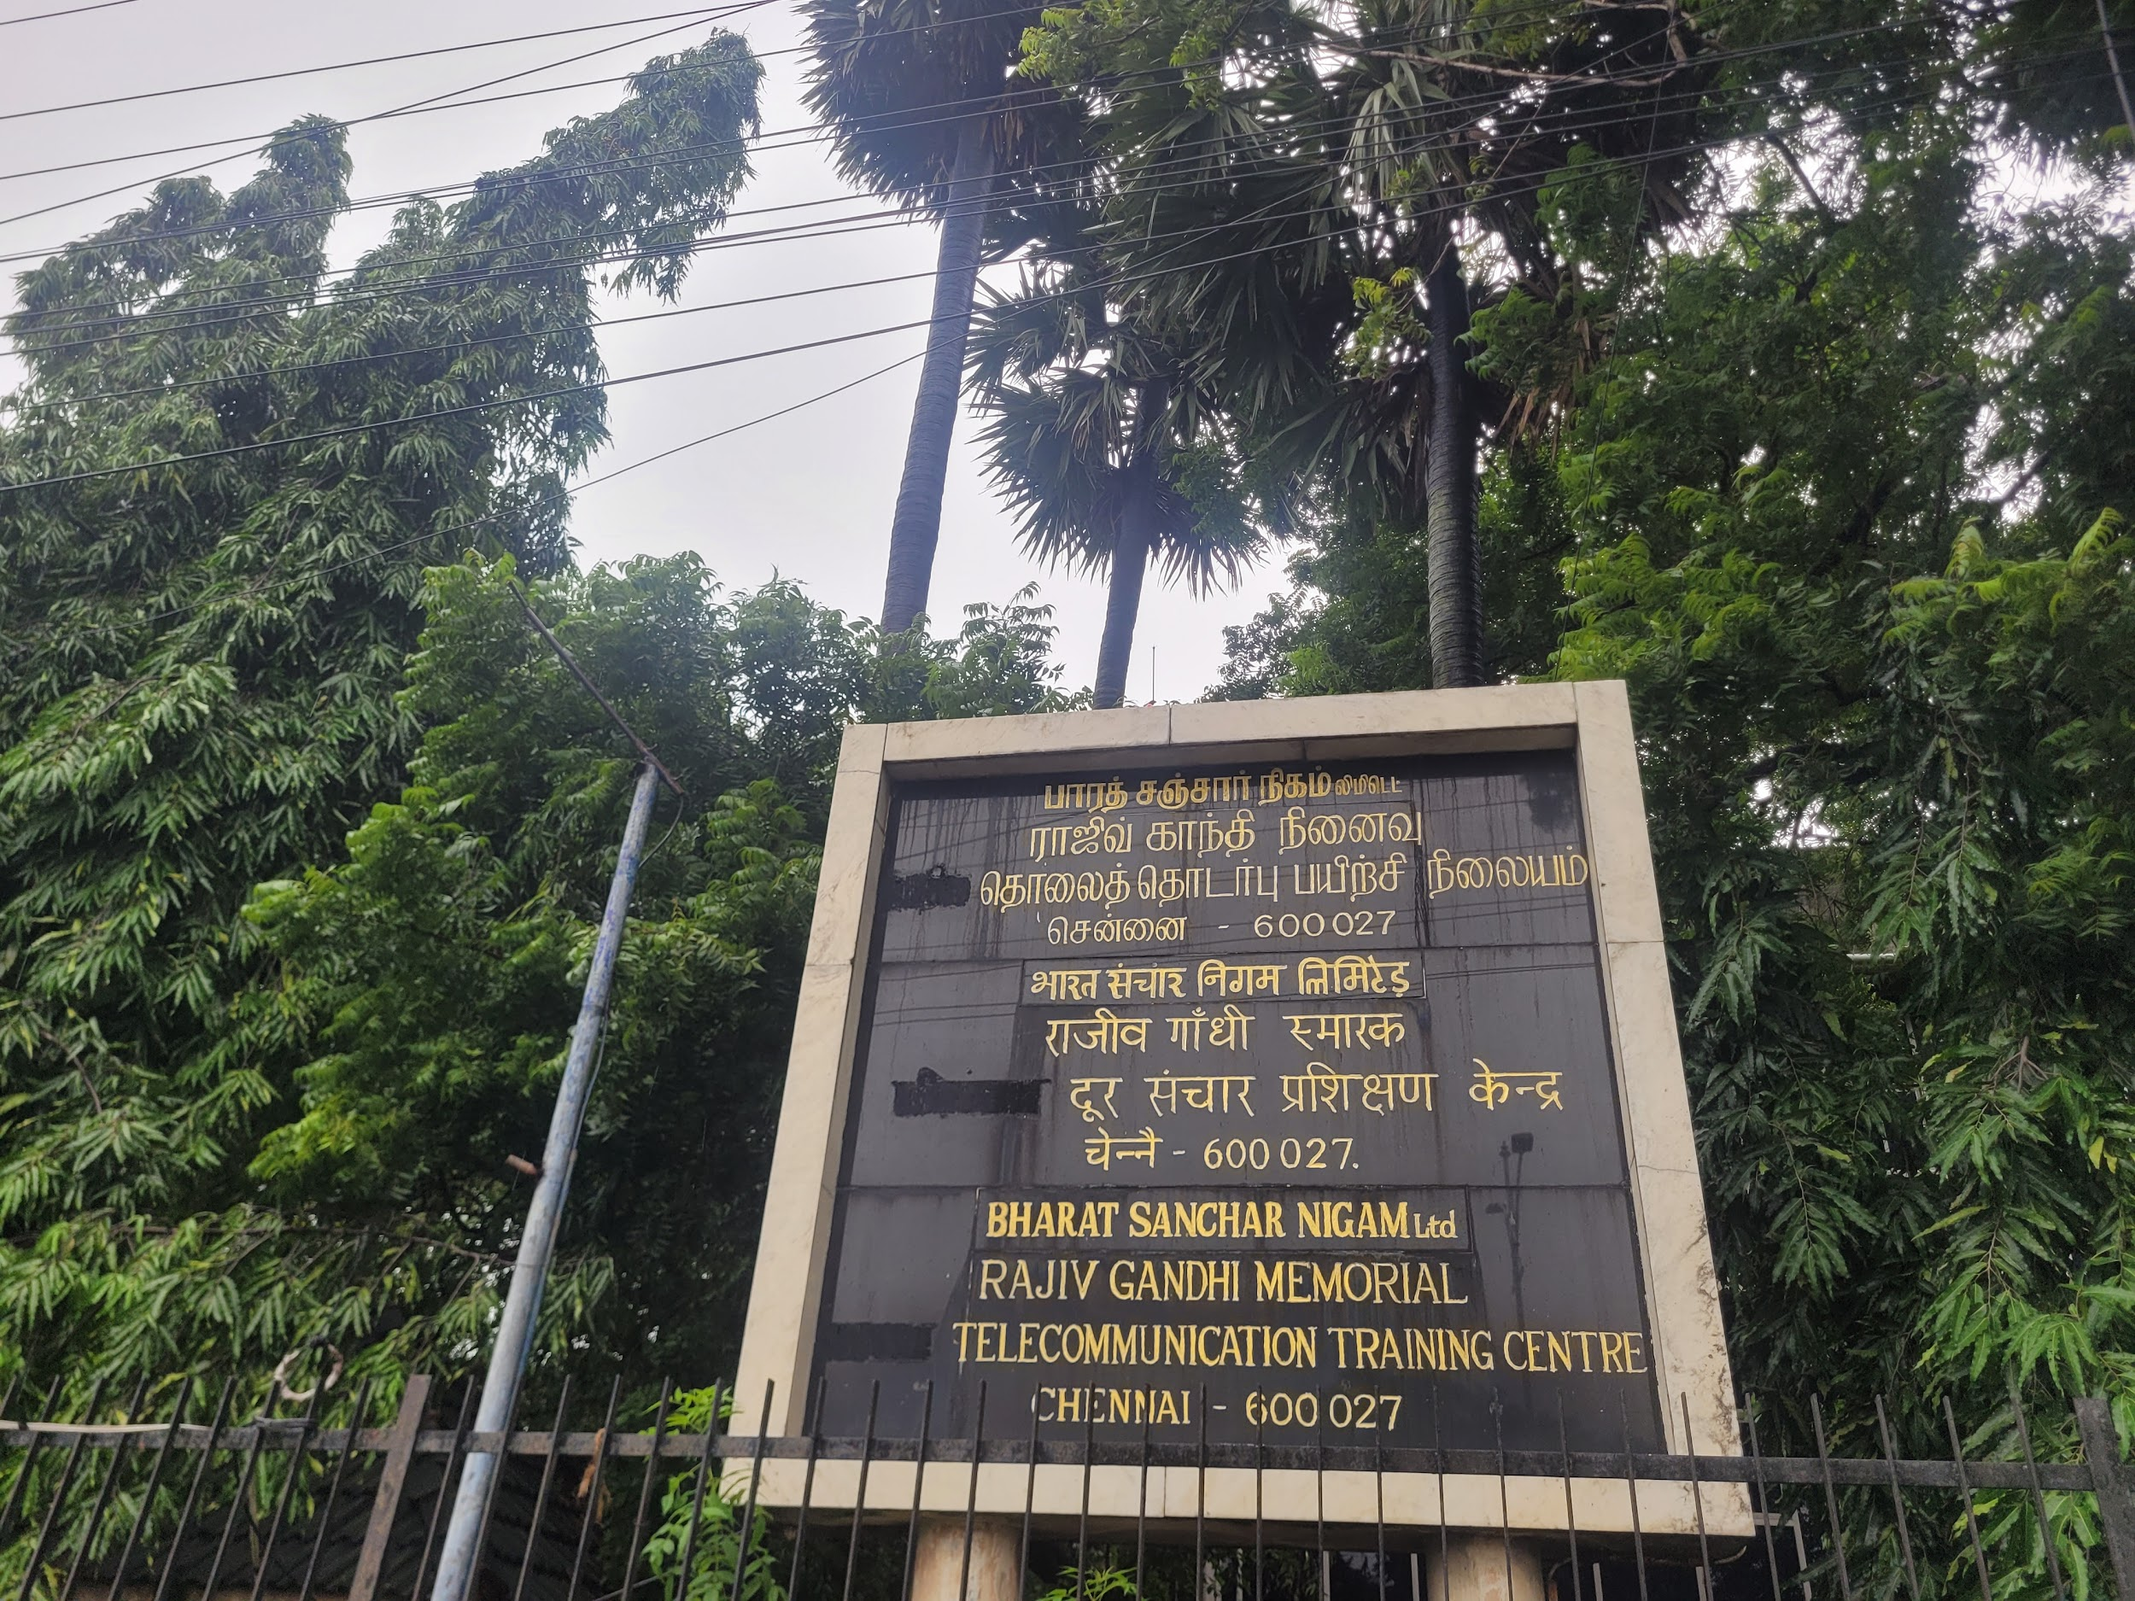
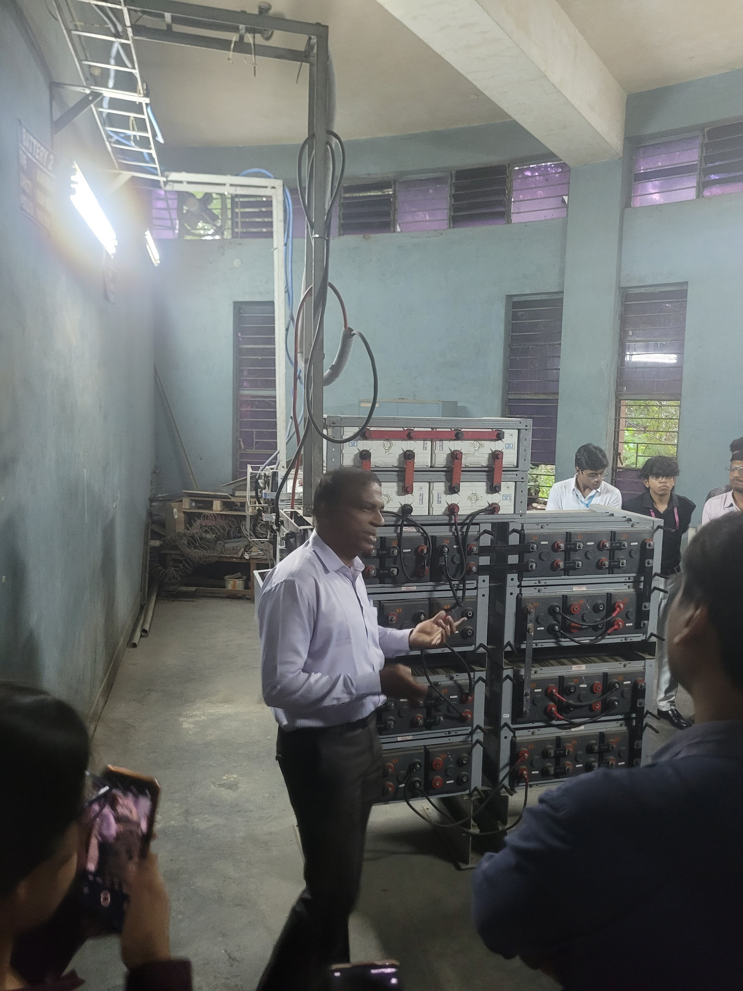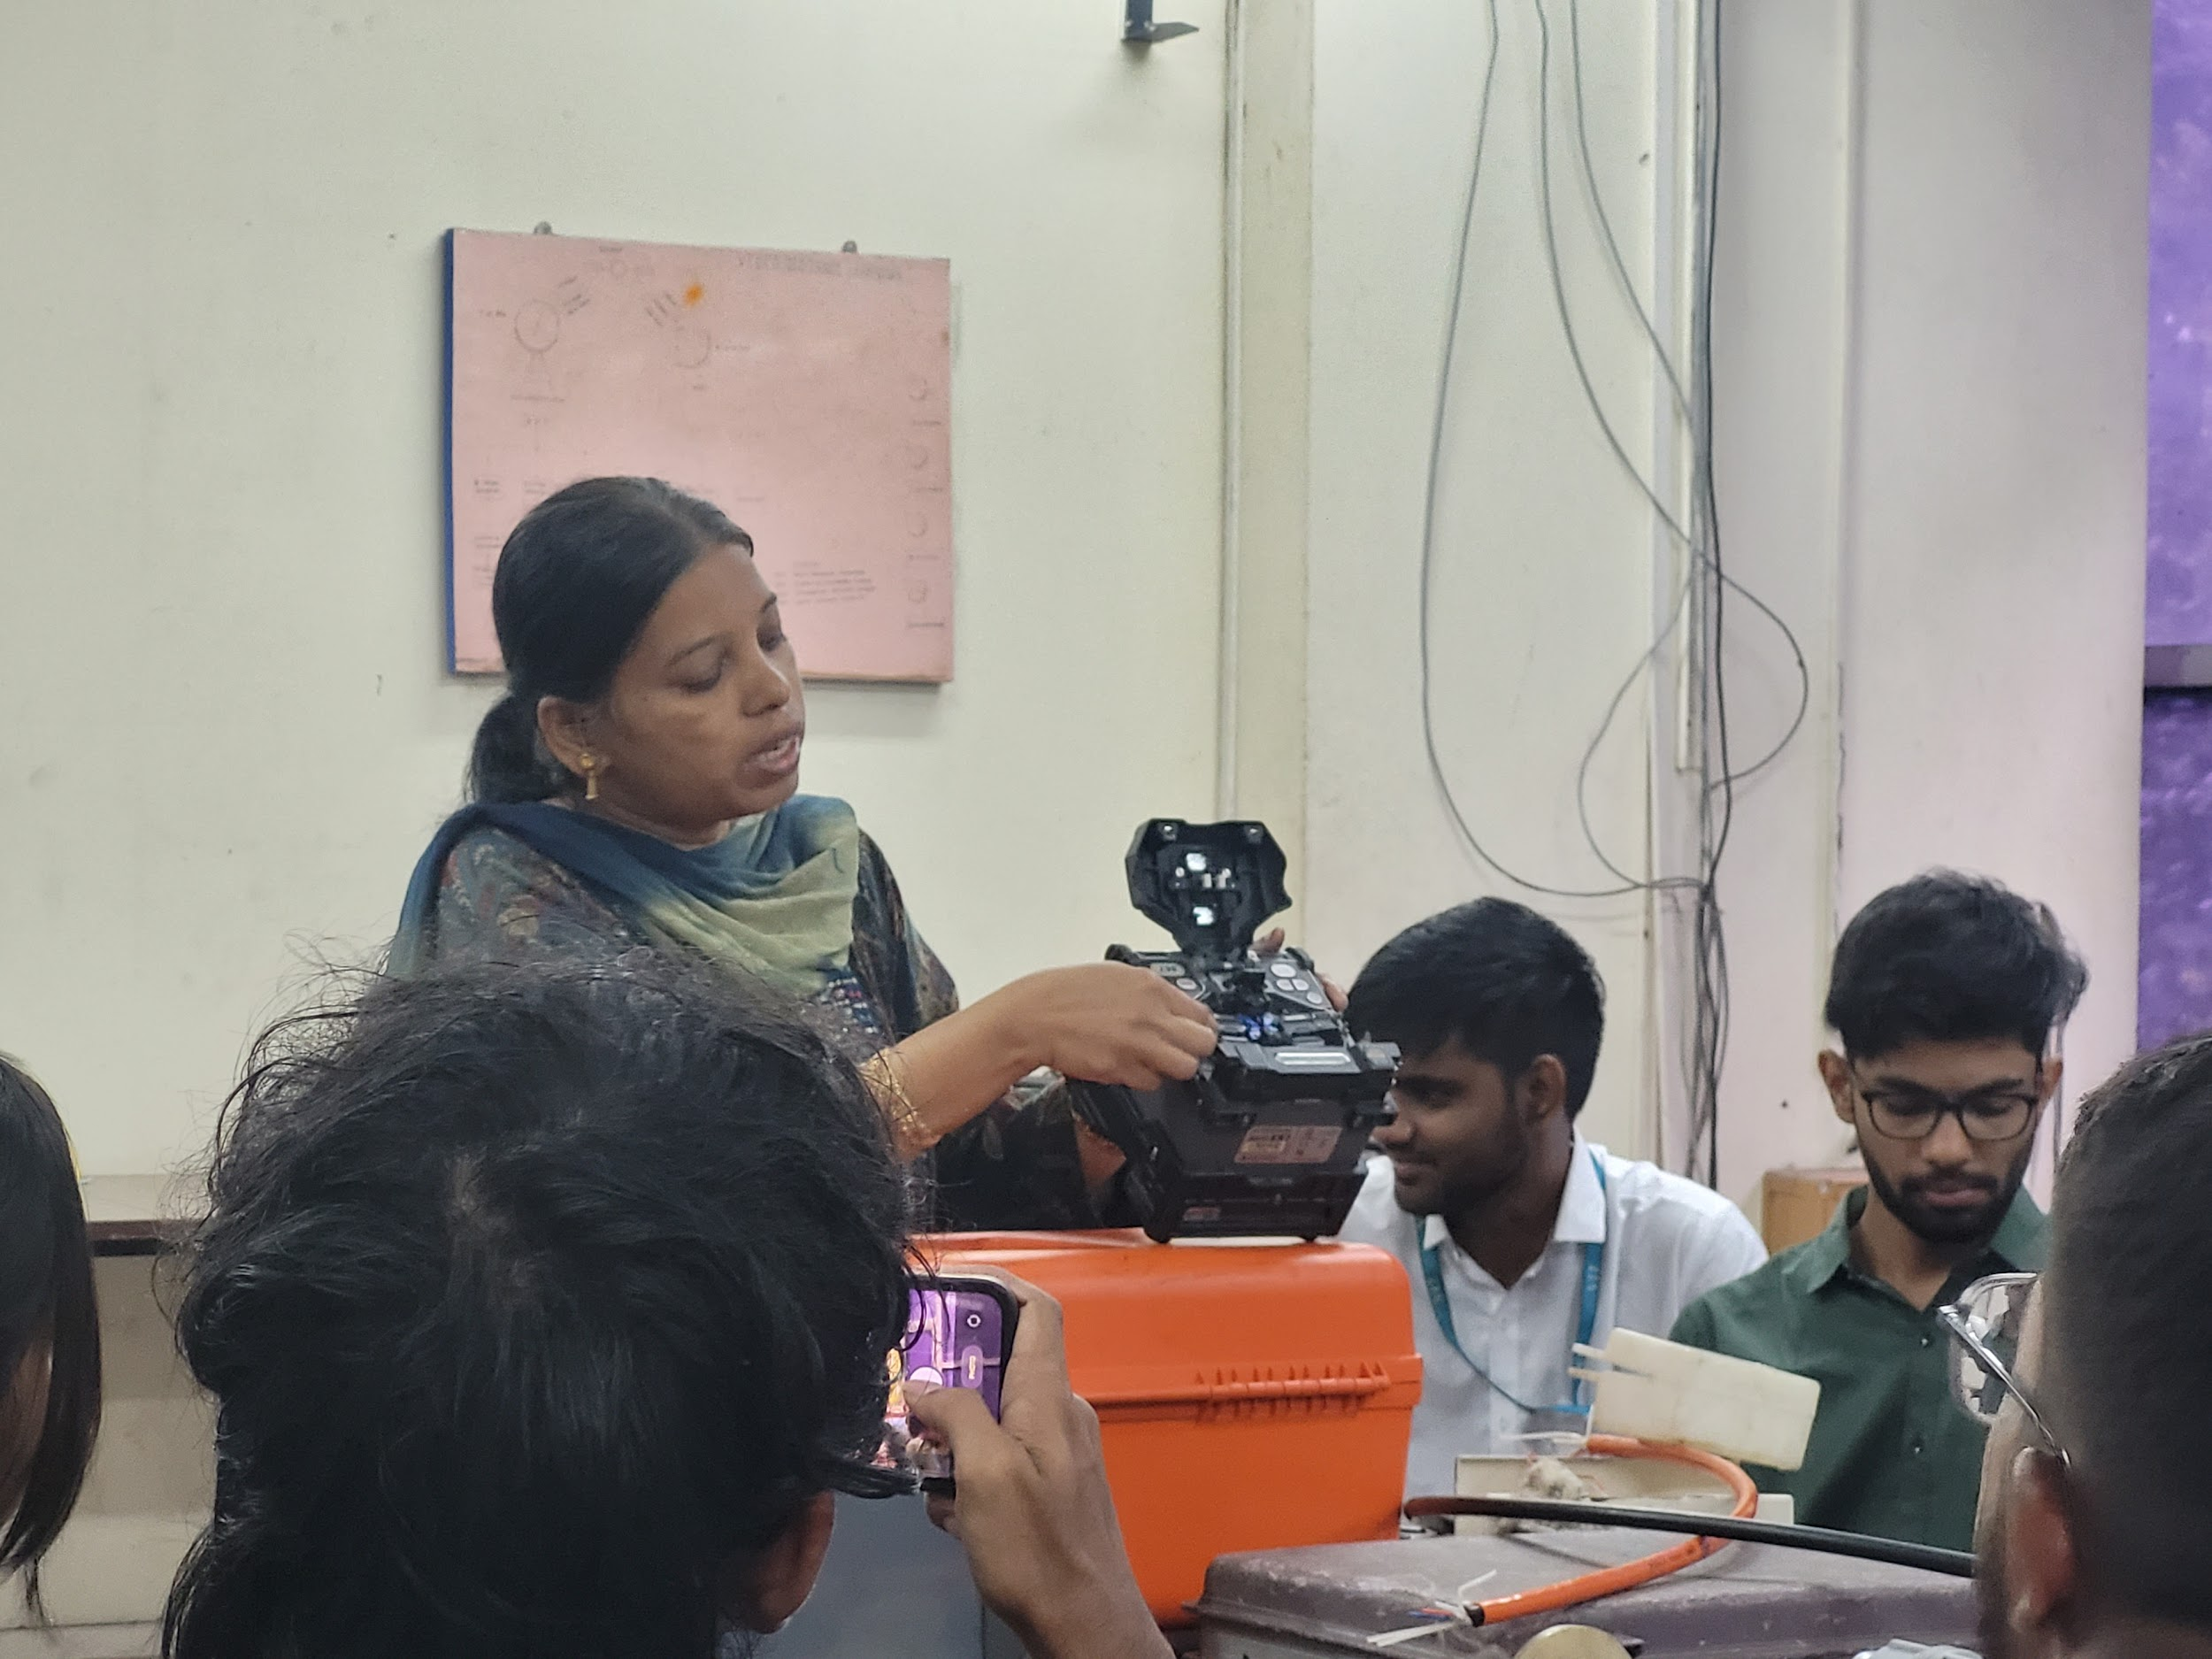
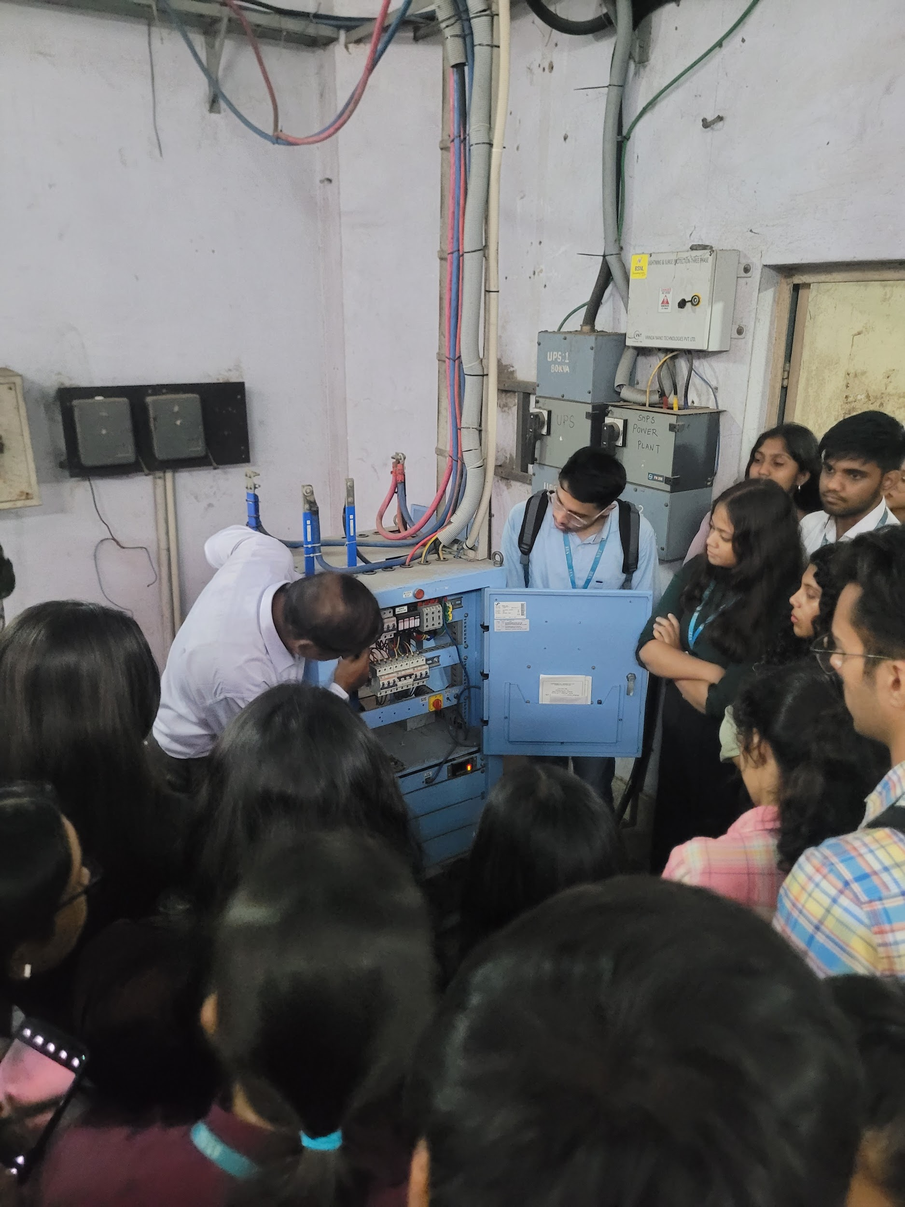
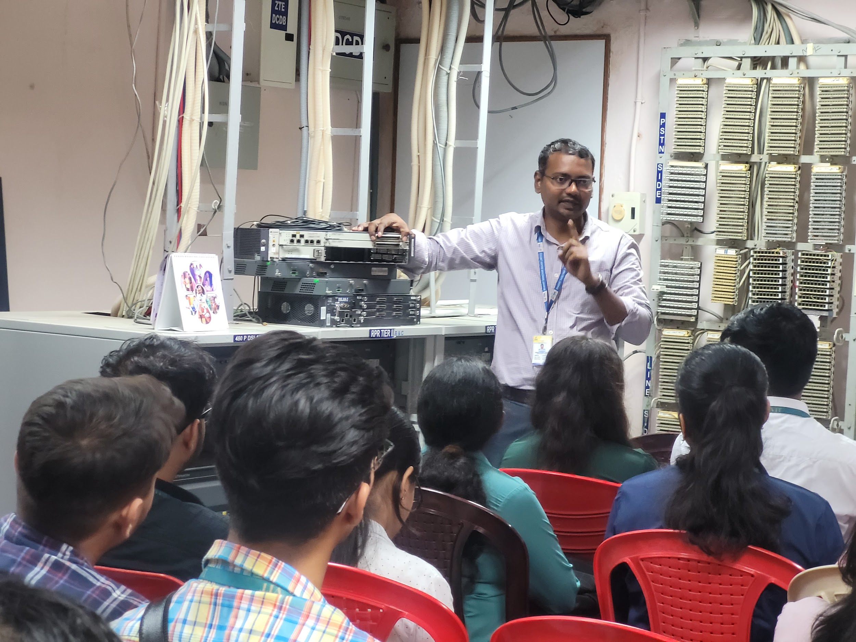

1.2.5 Feedback of the day – 2
The day was really insightful.
We learnt about existing trends of networking and how it's different in each countries.
We understand what happens to telecommunications when there is a catastrophe.
Undersrood How satellite communications are very different from ground connection or Fibre optics. And the advantages and disadvantages of it.

Day – 3 report

1.3.1 TVS - Ambattur

1.3.2 Objectives

1.3.3 Learning outcome

1.3.4 Photographs (Paste 4-5 good photogrpahs of hands on experience/visit)

1.3.5 Feedback of the day – 3

Day – 4 report

1.4.1 Industry Name –

1.4.2 Objectives

1.4.3 Learning outcome

1.4.4 Photographs (Paste 4-5 good photogrpahs of hands on experience/visit)

1.4.5 Feedback of the day – 4

Day – 5 report

1.5.1 Event/Industry Name –

1.5.2 Objectives

1.5.3 Learning outcome

1.5.4 Photographs (Paste 4-5 good photogrpahs of hands on experience/visit)

1.5.5 Feedback of the day – 5

Choice – 2
Bangalore

*****Similar details must be considered in all the cities as per schedule of the events

Conclusions

[As a conclusion, you need to identify three problem statements and write the same here. It must be derived from your programme proceedings]

